Pope Douglas Solid Waste Management
2004 Nokomis Street, Alexandria, MN 56308 (320)763-9340 Fax: (320)763-9342

Application for Incineration of Non-Hazardous Industrial Waste

STEP 1 Generator and Customer Information
Generator: 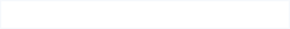 EPA ID #:
Contact Name: 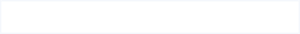 Title:
Address:
City: State: 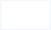 Zip: 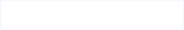
Phone #: Fax #:

Customer:
Contact Name:
Address:
City:
Phone #: Fax #:

STEP 2 Packaging

Type of Packaging:
Estimated Volume:
Lbs/year Packages/year

STEP 3 Waste Description & Physical Characteristics

Provide a brief description of the waste material and the process generating the waste material
Physical Characteristics
Density | Avg. lbs/ft^3 | Max. lbs/ft^3 | Min. lbs/ft^3
Flash Point | Avg. (F) | Max. (F) | Min. (F)
Heating Value | Avg. BTU/lb | Max. BTU/lb | Min. BTU/lb
pH | Avg. | Max. | Min.
Viscosity | Avg. cp | Max. cp | Min. cp
General Description
Chemical Description | Organic Waste | Inorganic Waste | Organic/Inorganic Mix
Physical State | Liquid | Solid | Semi-Solid
Phase/Layering | Uni-layer | Bi-Layer | Multi-Layer
Moisture | Liquid Fraction 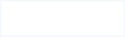 wt-(%) Solid Fraction wt-(%)
Appearance
Color
Odor
Other Characteristics
Reactivity | Explosive | May Detonate | Unstable | Normally Stable | Stable
Health Hazards | Deadly | Extreme Danger | Dangerous | Slight Danger | None
Other Hazards | Water Reactive Oxidizer radioactive

STEP 4 Required Analytical Testing
- Total Composition
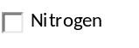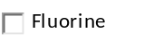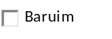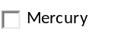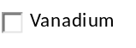
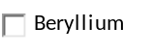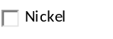
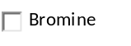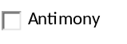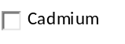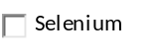
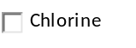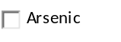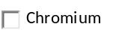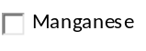
- TCLP Leachate – TCLP is required for individual compounds where the Total Composition result above exceeds 20 times the corresponding RCRA Limit.

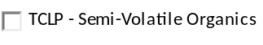
- Other Testing
Only required if contaminant is known to be present at the source or if trait is suspected.
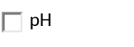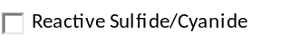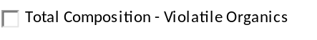
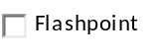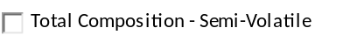

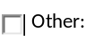

STEP 5 Petroleum Spill Media (Complete only if applicable)
Solids Present: (Check all that apply) Petroleum Products Present (Check all that apply)
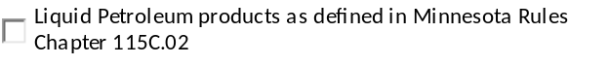

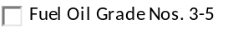

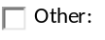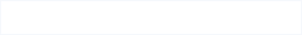
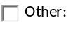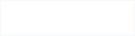
Please check the following:
True False

MPCA Spill Number 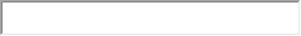
If any of the above boxes are checked “False”, please complete the following:
True False

Step 6 Waste Contaminated with Used Oil (Complete only if applicable)
Solids Present: (Check all that apply) Used Oils Present (Check all that apply)
Lubricants
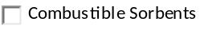
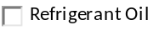
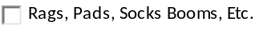 Heat Transfer Fluids
Note: Waste must not include steel oil filters
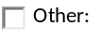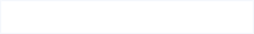

Hydraulic Fluids


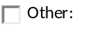
STEP 7 Generator Knowledge and Material Safety Data Sheets
Please check the following:
True False

STEP 8 Generator Certification
As an authorized representative of the generator, I hereby certify that the information above, including all attachments, is correct and that no deliberate or willful omission of composition or properties exist, and that all known or suspected hazards have been disclosed, and to the best of my knowledge, my industrial waste is not known to be hazardous, nor commingled with or contaminated with any hazardous materials. I understand the above information and all attachments will be reviewed and the Facility will either (1) approve my waste (2) request additional information, or (3) reject my waste for incineration. I understand that if I deliver to the Facility a waste material that does not conform with this profile (non-conforming waste), the Facility will notify me and will reject my waste and that I will be responsible for all costs and fees incurred by the Facility. I agree to hold harmless and indemnify the Pope and Douglas Join Solid Waste Management Board, Pope County, MN, Douglas County, MN, the Facility and its directors, officers, agents and employees from any and all liability, loss, costs, or damage resulting from all claims, lawsuits, or similar arising from the carrying out of operations or transactions associated with the disposal of the above materials as described in this Application for Incineration of Non-Hazardous Industrial Wastes.

Name (print): 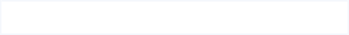 Date:

